<https://www.sant-just.com/chatbox/chatbox.html>

# Full screen typing issue

Full screen mode, the writing part is not coming. In none of the devices. It also happens in some other modes, check the screenshot below.   
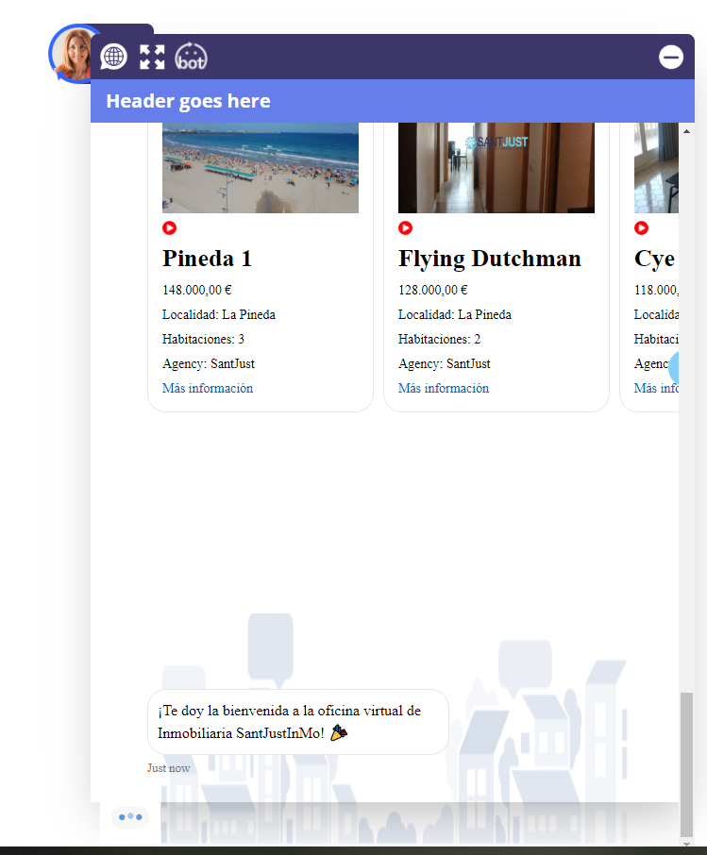

**Comment: Hey! please can you give samples of the codes you are adding and I add them on my side to fix this? because I can’t figure out the problem while I don’t have the codes on my side and please whenever you finish adding every single code please double check your console to see if you didn’t cause any JavaScript error.**

**am saying this because of this and in codes this can make other work improperly.**

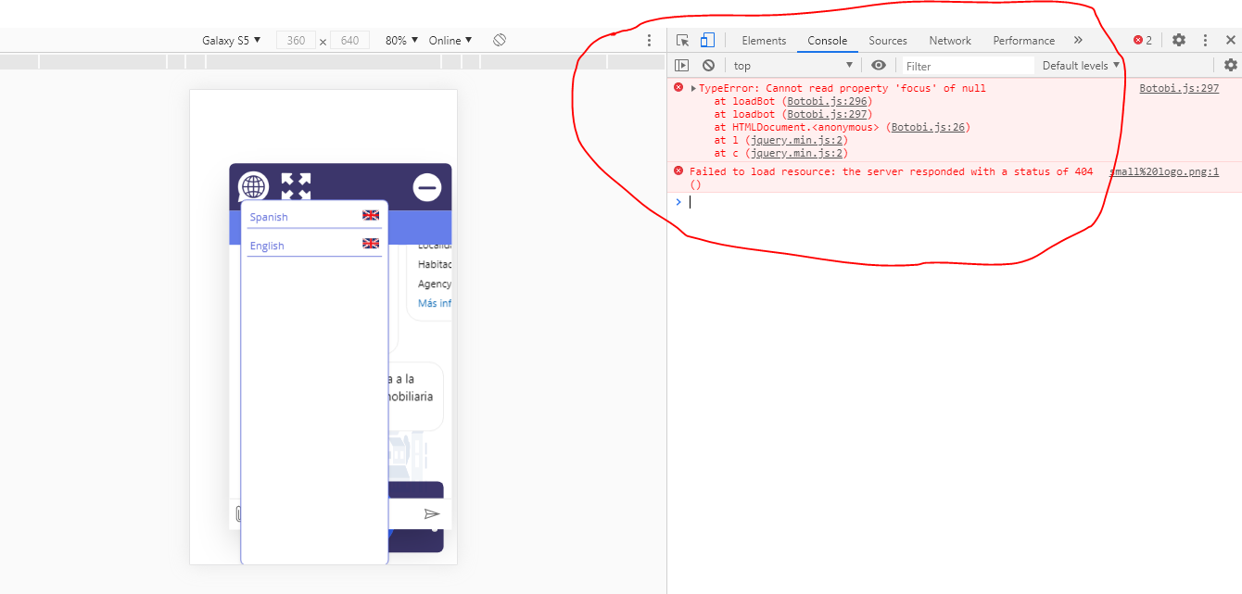

1. On initial loading the page is looking like below with a small window and as messages keep coming it grows to certain size. Do change to fix the height of this section. It should not shrink/expand. If message will be more than length of this section then scroll bar should appear

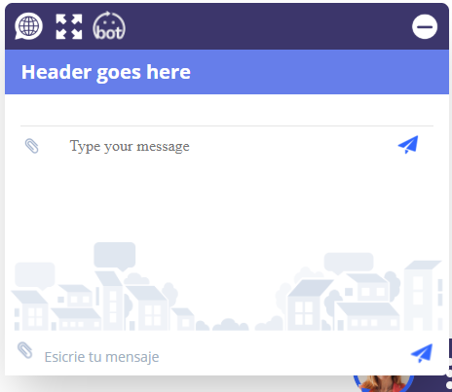

COMMENT : FIXED

Rashmi: He did nothing just removed the bottom section, alignment problem was there as it is. I did some changes in CSS and fixed this. As per me now this is working fine. please have a look at live url attached in the email

Comment: the same as above, on my side it is perfectly as you mentioned and humbly you can check this <https://sebastien15.github.io/chatbox/> when data increase the scroll bar appears, it does not increase or decrease at some point.

My recommendation is that you give me the codes you are adding so i can test them on my side then may be we can figure out the incoveniences.

1. on web btn click it is opening the language list as below, on any language option click this list should close. Language selector not working on mobile device: **Iphone and Ipad.** I cannot click on a language, it is not activating.

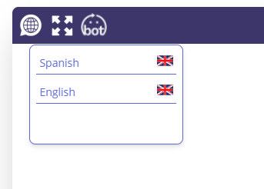

Comment: on my side still okay please check my link on both pc and phones the languages are working fine, may be fix that error and try again if it doesn’t work please gimme the codes I add them on my side.

1. First time full screen issue

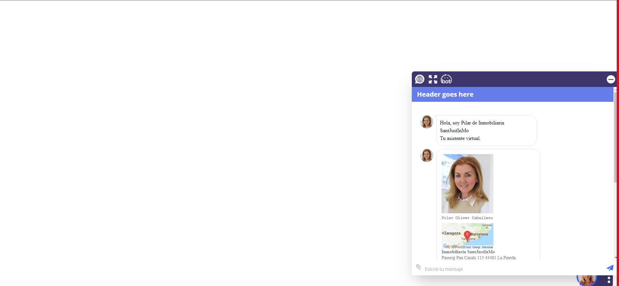

Open full screen

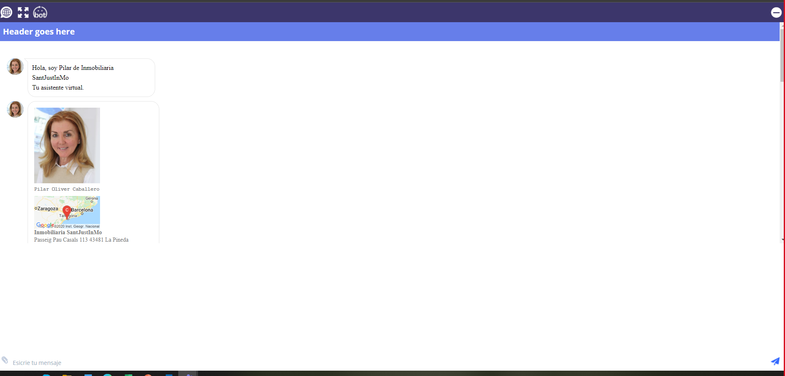

Ok, now go back to normal screen hitting the X.

Then screen will stay on upper left sided like this:

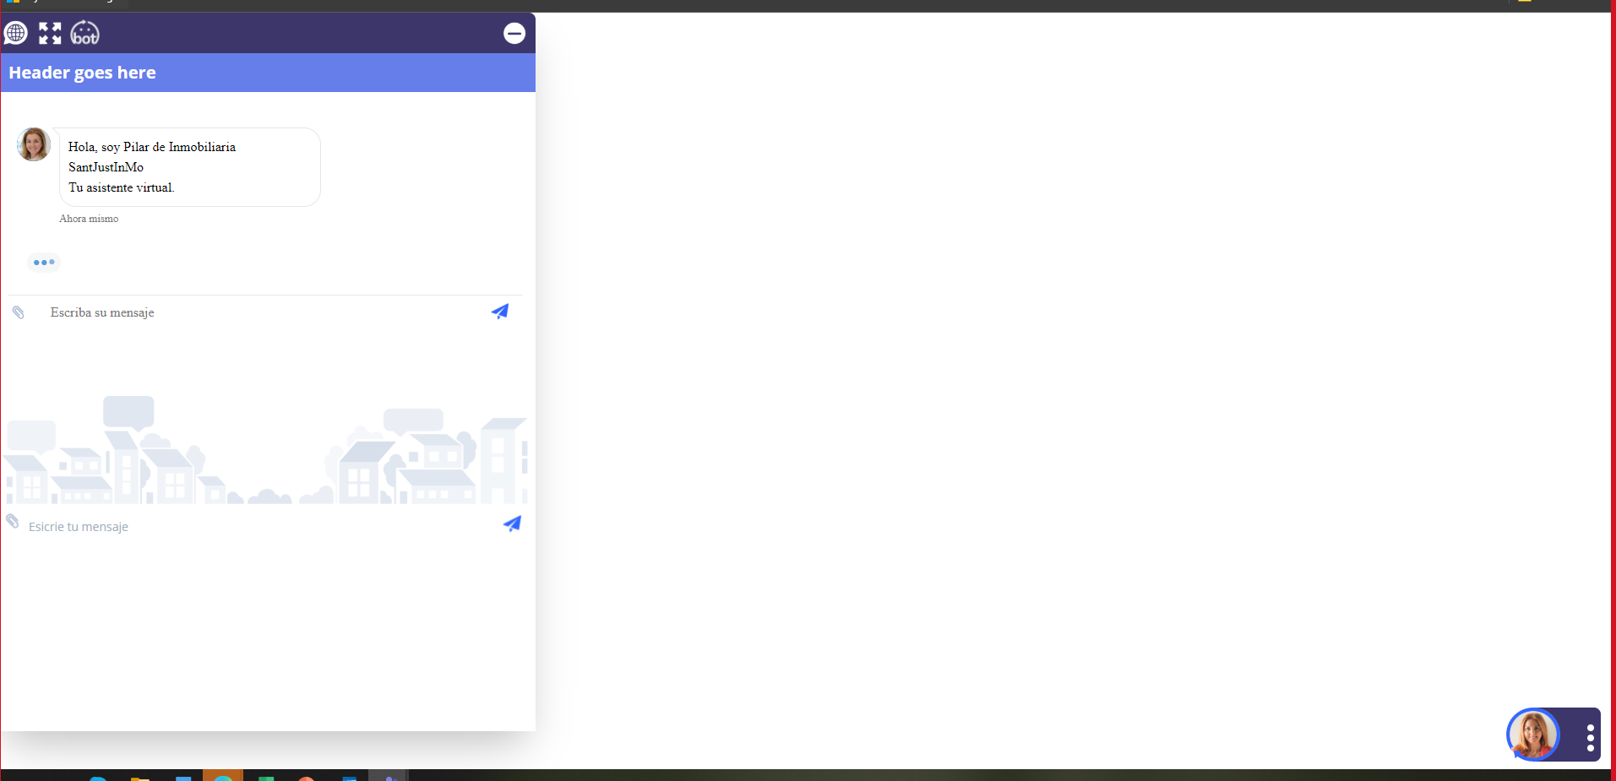

The second time it will open and close correctly.

**Comment: the first fix brought another issue that’s why it was working some times other times not, but for now it is fixed with no issue.**

1. Ipad design not ok

It is to stretchy for both horizontal and vertical position. Make it wider please.

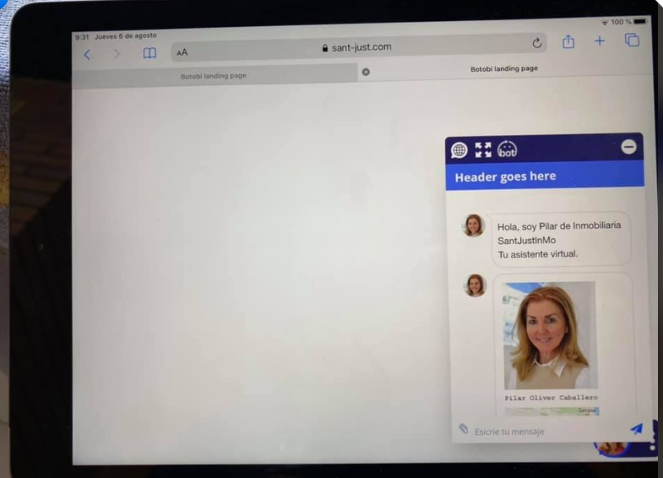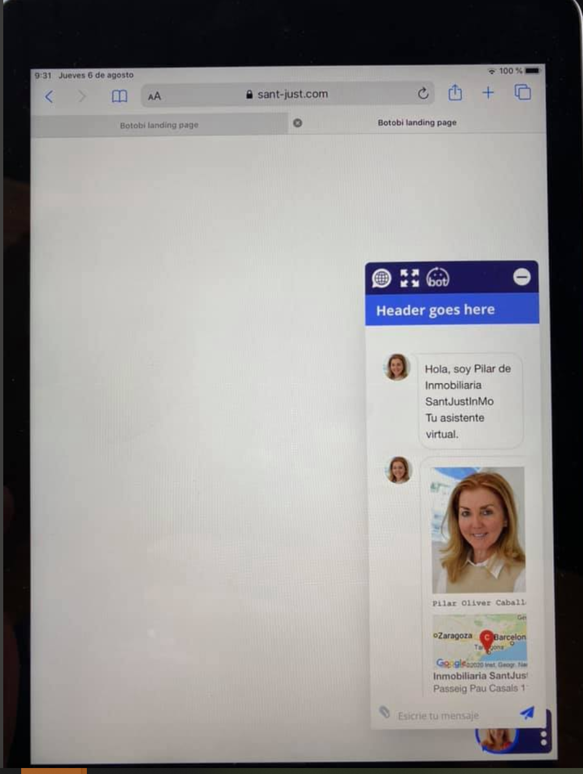

Comment: Please check my link it is fixed there was a class which was hindering the other